

Apache Airflow Interview Questions

Basic Level:-
- What is Apache Airflow, and why is it used?
Apache Airflow® is an open-source platform for developing, scheduling, and monitoring batch-oriented workflows. Airflow’s extensible Python framework enables you to build workflows connecting with virtually any technology. A web interface helps manage the state of your workflows. Airflow is deployable in many ways, varying from a single process on your laptop to a distributed setup to support even the biggest workflows.
- Explain the concept of Directed Acyclic Graphs (DAGs) in Airflow.
Directed: The flow goes in one direction from task to task. In a DAG, tasks are linked by dependencies, which means a task can only proceed once its dependencies are completed.
Acyclic: It doesn’t loop or cycle. There are no circular dependencies; a task cannot depend on itself, either directly or indirectly.
Graph: A DAG is a collection of nodes (tasks) and edges (dependencies), forming a structure that represents a workflow.
DAGs are code: In Airflow, DAGs are defined using Python code. You create a Python script to define the DAG and its structure.
Tasks as nodes: Each node in the DAG represents a unit of work or a task (e.g., running a Python function, querying a database, or executing a bash command).
Dependencies as edges: The edges between the nodes represent dependencies, meaning one task needs to finish before another can start.
Scheduling: DAGs are designed to be triggered on a schedule (e.g., daily, weekly) or based on specific conditions.
Task dependencies: You can define task dependencies using methods like:
  - set_upstream() – Defines that a task should run after another.
  - set_downstream() – Defines that a task should run before another.
  - >> or << operators – Simplified syntax to declare dependencies (task_1 >> task_2).
Example of Airflow DAG:-
from airflow import DAG
from airflow.operators.python_operator import PythonOperator
from datetime import datetime

# Define the DAG
dag = DAG(
'example_dag',
description='A simple DAG',
schedule_interval='0 12 * * *', # Runs daily at noon
start_date=datetime(2023, 1, 1),
catchup=False
)

# Define a Python task
def my_task():
print("Executing task")

# Create tasks
task_1 = PythonOperator(
task_id='task_1',
python_callable=my_task, ##Python code/function which needs to be executed
dag=dag
)

task_2 = PythonOperator(
task_id='task_2',
python_callable=my_task, ##Python code/function which needs to be executed
dag=dag
)

# Set dependencies
task_1 >> task_2 # task_2 depends on task_1

Example from official airflow website:-

from datetime import datetime

from airflow import DAG
from airflow.decorators import task
from airflow.operators.bash import BashOperator

# A DAG represents a workflow, a collection of tasks
with DAG(dag_id="demo", start_date=datetime(2022, 1, 1), schedule="0 0 * * *") as dag:
# Tasks are represented as operators
hello = BashOperator(task_id="hello", bash_command="echo hello")

@task()
def airflow():
print("airflow")

# Set dependencies between tasks
hello >> airflow()

Key Concepts:
- Parallelism: Airflow allows tasks within the same DAG to run in parallel if no dependencies exist between them.
- Dynamic DAGs: Because DAGs are defined in Python, you can dynamically generate them based on conditions, inputs, or configurations.
- Idempotency: DAGs are designed to be idempotent, meaning re-running the same workflow should yield the same results.
- How do you define tasks in Airflow?

DAGs vs Tasks:
- DAGs: A structure that holds the workflow (tasks and their dependencies).
- Tasks: The individual units of work within a DAG.

- What are the different types of operators in Airflow?

1. PythonOperator
Used to run a Python function as a task.
from airflow import DAG
from airflow.operators.python_operator import PythonOperator
from datetime import datetime

def my_python_task():
print("Executing Python task")

# Define the DAG
dag = DAG('example_dag', start_date=datetime(2023, 1, 1))

# Define the task
task_1 = PythonOperator(
task_id='python_task',
python_callable=my_python_task, # The Python function to run
dag=dag
)

2. BashOperator
Used to execute Bash commands.
from airflow.operators.bash_operator import BashOperator

task_2 = BashOperator(
task_id='bash_task',
bash_command='echo "Hello from Bash"',
dag=dag
)

3. PostgresOperator
Used to execute SQL queries on a PostgreSQL database.
from airflow.operators.postgres_operator import PostgresOperator

task_3 = PostgresOperator(
task_id='postgres_task',
postgres_conn_id='my_postgres_connection',
sql='SELECT * FROM my_table;',
dag=dag
)

4. EmailOperator
Used to send emails.
from airflow.operators.email_operator import EmailOperator

task_4 = EmailOperator(
task_id='send_email',
to='user@example.com',
subject='Airflow Email',
html_content='<p>This is an email from Airflow</p>',
dag=dag
)

5. DummyOperator
This operator does nothing and is often used as a placeholder or to organize task dependencies.
from airflow.operators.dummy_operator import DummyOperator

start_task = DummyOperator(
task_id='start',
dag=dag
)

Defining Multiple Tasks
You can define multiple tasks in the same DAG and set dependencies between them. Here's an example where multiple tasks are created and their order is set:

# Define more tasks
task_2 = PythonOperator(
task_id='second_task',
python_callable=my_python_task,
dag=dag
)

task_3 = BashOperator(
task_id='third_task',
bash_command='echo "Task 3"',
dag=dag
)

# Set dependencies between tasks
task_1 >> task_2 # task_2 runs after task_1
task_2 >> task_3 # task_3 runs after task_2

Task Dependencies:
You can define the sequence in which tasks are executed by specifying dependencies:
- task_1 >> task_2: task_2 will only run after task_1 is complete.
- task_2.set_upstream(task_1): Same as above, but more explicit syntax.
- task_3.set_downstream(task_4): task_4 will run after task_3 is complete.
- How can you schedule a DAG in Airflow?

1. Cron Expressions:
Airflow uses cron expressions to allow flexible scheduling. A cron expression follows the format:
<minute> <hour> <day_of_month> <month> <day_of_week>

dag = DAG(
'daily_dag',
schedule_interval='30 2 * * *',
start_date=datetime(2023, 1, 1)
)

2. Preset Intervals:
Airflow provides several preset options to simplify common scheduling scenarios. These presets are strings like '@daily', '@hourly', etc.
- @once: Run the DAG only once when triggered manually.
- @hourly: Run the DAG every hour.
- @daily: Run the DAG once a day at midnight (00:00 UTC).
- @weekly: Run the DAG once a week at midnight on Sunday.
- @monthly: Run the DAG once a month at midnight of the first day of the month.
- @yearly (or @annually): Run the DAG once a year at midnight of January 1st.
Example for running daily:
dag = DAG(
'daily_dag',
schedule_interval='@daily',
start_date=datetime(2023, 1, 1)
)

3. Time Delta (Relative Time Scheduling):
If you want the DAG to run at intervals based on when it last ran, you can use the timedelta object from Python’s datetime module to specify relative intervals.
Example for running every 5 minutes:
from datetime import timedelta

dag = DAG(
'five_minute_dag',
schedule_interval=timedelta(minutes=5),
start_date=datetime(2023, 1, 1)
)

4. No Schedule (Manual Trigger Only):
You can set a DAG to not run automatically and instead only be triggered manually. In this case, you set schedule_interval=None.
dag = DAG(
'manual_dag',
schedule_interval=None, # This DAG will only run when triggered manually
start_date=datetime(2023, 1, 1)
)

Important Parameters for Scheduling:

1. start_date:
- start_date specifies when Airflow should start scheduling the DAG.
- It needs to be in the past or the present when the DAG is triggered for the first time. Airflow does not run DAGs retroactively unless catchup is enabled.

2. catchup (Default=True):
By default, Airflow will "catch up" on all the missed DAG runs between the start_date and the current date. This behavior can be disabled by setting catchup=False.

Intermediate Level:

- How do you monitor and manage workflows in Airflow?
  - Airflow Web Interface (UI)
  - Airflow Command Line Interface (CLI)
  - Alerts and Notifications
  - SLAs (Service Level Agreements
  - Retries and Failure Handling

Tasks | Key Commands
Start/Stop a DAG: | airflow dags pause <dag_id>  airflow dags unpause <dag_id>
Trigger a DAG manually: | airflow dags trigger <dag_id>
List all DAGs: | airflow dags list
List DAG runs: | airflow dags list-runs <dag_id>
List tasks within a DAG: | airflow tasks list <dag_id>
Check the status of a task: | airflow tasks state <dag_id> <task_id> <execution_date>
View task logs: | airflow tasks logs <dag_id> <task_id> <execution_date>
Mark a task as successful: | airflow tasks mark_success <dag_id> <task_id> <execution_date>
Email Notification:-
# Example of Email Notification
dag = DAG(
'example_dag',
default_args={
'email': ['your_email@example.com'],
'email_on_failure': True,
'email_on_retry': False,
},
schedule_interval='@daily',
)
SLA:-
task_1 = PythonOperator(
task_id='python_task',
python_callable=my_function,
sla=timedelta(hours=1), # SLA: task must complete within 1 hour
dag=dag
)
Retries and failure handling:-
default_args = {
'retries': 3, # Number of retries
'retry_delay': timedelta(minutes=5), # Delay between retries
}

- Explain the difference between Airflow Sensors and Operators.

Operators are discussed above. Sensor. A Sensor is a type of operator that is specifically designed to wait for a certain condition to be met before proceeding. Sensors are stateful because they keep checking (polling) until their condition is satisfied. They are often used for tasks that depend on external systems or events, such as waiting for a file to appear in a directory, a partition to be added to a database, or an API to return a specific status.

Types of Sensors:
- FileSensor: Waits for a file to appear in a specific location.
- ExternalTaskSensor: Waits for an external task in another DAG to complete.
- HttpSensor: Waits for an API response or a certain status from an HTTP request.
- S3KeySensor: Waits for a file or object to appear in an S3 bucket.

  - Action Operator e.g PostgresOperator
  - Transfer Operator e.g S3toSnowflakeOperator
  - Sensor Operator e.g FileSensor
Example of file sensor:-

from airflow.sensors.filesystem import FileSensor

wait_for_file = FileSensor(
task_id='wait_for_file',
filepath='/path/to/my/file.csv',
poke_interval=60, # Check every 60 seconds
dag=dag
)

from airflow import DAG
from airflow.sensors.python import PythonSensor

def _condition():
return False

with DAG(
dag_id="sensor",
start_date=datetime(2021, 1, 1),
schedule="@daily",
catchup=False,
):
waiting_for_condition = PythonSensor(
task_id="waiting_for_condition",
python_callable=_condition,
poke_interval=60,
timeout=7 * 24 * 60 * 60
)
In the example above, the Sensor checks _condition to be true every 60 seconds by default (poke_interval). Since _condition always returns False, the Sensor will continue checking every 60 seconds until it times out after 7 days (7 * 24 * 60 * 60 by default). When the Sensor times out, it is marked failed.

from airflow.decorators import dag, task
from airflow.providers.amazon.aws.sensors.s3 import S3KeySensor
from datetime import datetime

@dag(
schedule=None,
start_date=datetime(2023, 1, 1),
tags=['aws'],
catchup=False
)
def my_dag():

wait_for_file = S3KeySensor(
task_id="wait_for_file",
aws_conn_id="aws_s3",
bucket_key="s3://marc-airflow/data_*",
wildcard_match=True,
)

@task
def process_file():
print("I processed the file!")

wait_for_file >> process_file()

my_dag()

Aspect | Operators | Sensors
Purpose | Perform an action (e.g., run code, execute a script). | Wait for a condition to be met (e.g., a file to appear, a task to complete).
State | Stateless (run and complete). | Stateful (can keep running until a condition is met).
Execution Mode | Executes immediately when dependencies are met. | Keeps checking/polling until the condition is satisfied.
Resource Usage | Minimal once executed. | Can be resource-intensive if waiting for a long time (unless using reschedule mode).
Action vs. Condition | Performs an action such as querying, sending, executing, etc. | Checks for an external condition, like a file or data being ready.
Common Use Cases | Run scripts, query databases, send emails. | Wait for file creation, task completion, API response, etc.

- What are XComs in Airflow, and how do you use them?

- from airflow import DAG
- from airflow.operators.python_operator import PythonOperator
- from datetime import datetime
- import requests

- # Task 1: Fetch data from an API
- def fetch_data(**kwargs):
- # Simulate an API call (e.g., get user data from a public API)
- response = requests.get("https://jsonplaceholder.typicode.com/users")

- if response.status_code == 200:
- data = response.json() # Assume we're getting JSON data
- # Push the fetched data into XCom using return (default key is 'return_value')
- return data
- else:
- raise ValueError("Failed to fetch data from API")

- # Task 2: Process the fetched data (e.g., filter out data)
- def process_data(**kwargas):
- ti = kwargs['ti']
- # Pull the data from Task 1 (fetch_data) using XCom using a defalult key which is return value
- fetched_data = ti.xcom_pull(task_ids='fetch_task')

- # Example transformation: Filter users from a specific company
- filtered_data = [user for user in fetched_data if user['company']['name'] == 'Romaguera-Crona']

- # Push the processed data into XCom for downstream use
- ti.xcom_push(key='processed_data', value=filtered_data)

- # Task 3: Save the processed data to a database or file (mocked here)
- def save_data(**kwargs):
- ti = kwargs['ti']
- # Pull the processed data from Task 2 (process_data) using a custom XCom key
- processed_data = ti.xcom_pull(task_ids='process_task', key='processed_data')

- # Mock saving the data (in reality, this could be writing to a database or a file)
- print(f"Saving the following data: {processed_data}")

- # Define the DAG
- with DAG(
- dag_id='xcom_practical_example',
- start_date=datetime(2023, 1, 1),
- schedule_interval='@daily',
- catchup=False,
- ) as dag:

- # Define tasks
- fetch_task = PythonOperator(
- task_id='fetch_task',
- python_callable=fetch_data,
- provide_context=True
- )

- process_task = PythonOperator(
- task_id='process_task',
- python_callable=process_data,
- provide_context=True
- )

- save_task = PythonOperator(
- task_id='save_task',
- python_callable=save_data,
- provide_context=True
- )

- # Set task dependencies
- fetch_task >> process_task >> save_task
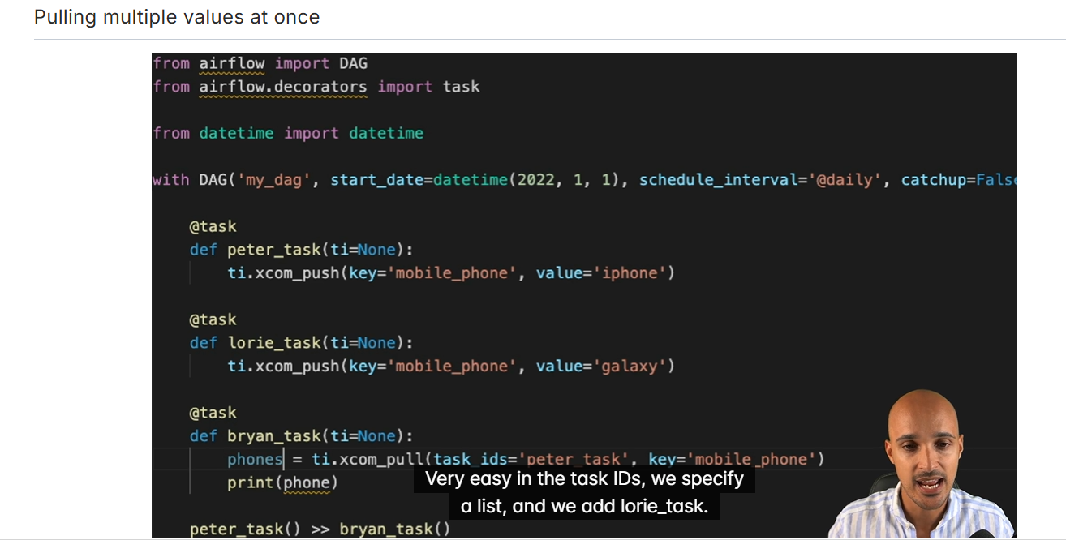

from airflow import DAG
from airflow.operators.python import PythonOperator
import pendulum
from airflow.models.taskinstance import TaskInstance as ti

def _transform(ti: ti):
import requests
resp = requests.get(f'https://swapi.dev/api/people/1').json()
print(resp)
my_character = {}
my_character["height"] = int(resp["height"]) - 20
my_character["mass"] = int(resp["mass"]) - 13
my_character["hair_color"] = "black" if resp["hair_color"] == "blond" else "blond"
my_character["eye_color"] = "hazel" if resp["eye_color"] == "blue" else "blue"
my_character["gender"] = "female" if resp["gender"] == "male" else "female"
ti.xcom_push("character_info", my_character)

def _transform2(ti: ti):
import requests
resp = requests.get(f'https://swapi.dev/api/people/2').json()
print(resp)
my_character = {}
my_character["height"] = int(resp["height"]) - 50
my_character["mass"] = int(resp["mass"]) - 20
my_character["hair_color"] = "burgundy" if resp["hair_color"] == "blond" else "brown"
my_character["eye_color"] = "green" if resp["eye_color"] == "blue" else "black"
my_character["gender"] = "male" if resp["gender"] == "male" else "female"
ti.xcom_push("character_info", my_character)

def _load(values):
print(values)

with DAG(
'xcoms_demo_4',
schedule = None,
start_date = pendulum.datetime(2023,3,1),
catchup = False
):

t1 = PythonOperator(
task_id = '_transform',
python_callable = _transform
)
t2 = PythonOperator(
task_id = 'load',
python_callable = _load,
op_args = ["{{ ti.xcom_pull(task_ids=['_transform','_transform2'], key='character_info') }}"]
)
t3 = PythonOperator(
task_id = '_transform2',
python_callable = _transform2,
)
[t1,t3] >> t2

from airflow.decorators import dag, task
from datetime import datetime
import requests

from airflow.sensors.base import PokeReturnValue

@dag(start_date=datetime(2022, 12, 1), schedule="@daily", catchup=False)
def sensor_decorator():

@task.sensor(poke_interval=30, timeout=3600, mode="poke")
def check_shibe_availability() -> PokeReturnValue:
r = requests.get("http://shibe.online/api/shibes?count=1&urls=true")
print(r.status_code)

if r.status_code == 200:
condition_met = True
operator_return_value = r.json()
else:
condition_met = False
operator_return_value = None
print(f"Shibe URL returned the status code {r.status_code}")

return PokeReturnValue(is_done=condition_met, xcom_value=operator_return_value)

# print the URL to the picture
@task
def print_shibe_picture_url(url):
print(url)

print_shibe_picture_url(check_shibe_availability())

sensor_decorator()

  - How do you handle dependencies between tasks in a DAG?

1. Using >> and << Operators (Preferred Method)
The most common and intuitive way to define dependencies is by using the >> (set downstream) and << (set upstream) operators.

Example:
task1 >> task2 # task2 will execute after task1
task2 << task3 # task3 will execute before task2
This is equivalent to:
task1.set_downstream(task2)
task3.set_upstream(task2)

Chain multiple tasks:

You can easily chain multiple tasks with the >> operator.
task1 >> task2 >> task3 # task2 follows task1, task3 follows task2

2. Using set_downstream and set_upstream Methods
You can manually set dependencies using set_downstream() and set_upstream() methods.

Example:
task1.set_downstream(task2) # task2 depends on task1
task2.set_upstream(task3) # task2 depends on task3

3. Handling Multiple Dependencies
You can create complex dependencies between tasks using multiple downstream or upstream tasks.

Example:
task1 >> [task2, task3] # task2 and task3 both depend on task1

[task2, task3] >> task4 # task4 depends on both task2 and task3

  - Explain the process of scaling Airflow for large-scale workflows.

Scaling Strategies:
- Use the Celery or Kubernetes Executor to distribute tasks across multiple worker nodes or pods.
- Run multiple schedulers for better load balancing and high availability.
- Deploy multiple web servers behind a load balancer to handle increased UI traffic.
- Scale the metadata database with read replicas and vertical scaling.
- Optimize DAG and task concurrency settings to allow more parallel execution.
- Use distributed log storage to manage task logs at scale.
- Set up comprehensive monitoring and alerting for proactive issue detection.
- Implement high availability for key components like the scheduler and database.
- Leverage containerization and IaC for easy deployment and scaling.

  - Airflow scheduling of Py script consist of API:-

from airflow import DAG
from airflow.operators.python import PythonOperator
from airflow.providers.amazon.aws.hooks.s3 import S3Hook
from airflow.providers.postgres.hooks.postgres import PostgresHook
from datetime import datetime, timedelta
import requests
import json
import os

# CONFIG
BUCKET_NAME = 'your-s3-bucket-name'
S3_KEY = 'api-data/bitcoin_price.json'
LOCAL_PATH = '/tmp/bitcoin_price.json'
REDSHIFT_TABLE = 'public.bitcoin_price'
REDSHIFT_CONN_ID = 'redshift_default'

default_args = {
'owner': 'airflow',
'retry_delay': timedelta(minutes=5),
'retries': 1,
}

with DAG(
'api_to_s3_redshift',
default_args=default_args,
schedule_interval='0 6 * * *',
start_date=datetime(2024, 1, 1),
catchup=False,
tags=['api', 's3', 'redshift']
) as dag:

def extract_and_save():
url = "https://api.coindesk.com/v1/bpi/currentprice.json"
response = requests.get(url)
data = response.json()

with open(LOCAL_PATH, 'w') as f:
json.dump(data, f)

def upload_to_s3():
s3 = S3Hook(aws_conn_id='aws_default')
s3.load_file(
filename=LOCAL_PATH,
bucket_name=BUCKET_NAME,
key=S3_KEY,
replace=True
)

def load_into_redshift():
redshift = PostgresHook(postgres_conn_id=REDSHIFT_CONN_ID)

# Assumes Redshift table already exists and has a matching structure
sql = f"""
COPY {REDSHIFT_TABLE}
FROM 's3://{BUCKET_NAME}/{S3_KEY}'
IAM_ROLE 'arn:aws:iam::<your-account-id>:role/<your-redshift-role>'
FORMAT AS JSON 'auto'
TIMEFORMAT AS 'auto';
"""

redshift.run(sql)

t1 = PythonOperator(
task_id='extract_api_data',
python_callable=extract_and_save
)

t2 = PythonOperator(
task_id='upload_to_s3',
python_callable=upload_to_s3
)

t3 = PythonOperator(
task_id='load_to_redshift',
python_callable=load_into_redshift
)

t1 >> t2 >> t3

Advanced Level: Out of scope
- How do you implement retry logic and error handling in Airflow tasks?
Retries and failure handling:-

default_args = {
'retries': 3, # Number of retries
'retry_delay': timedelta(minutes=5), # Delay between retries
}
- Describe how you would set up and manage Airflow in a production environment.
- How can you customize and extend Airflow with plugins?
- Explain the process of dynamically generating DAGs in Airflow.
- Discuss best practices for optimizing Airflow performance and resource utilization.
- How do you manage and secure sensitive data within Airflow workflows?

Install Airflow
- There are two primary ways to install Airflow on a local machine: Python Package Index or Containerization Solutions (e.g., Docker, Podman)
  - The Python Package Index
    - This method is great for anyone who is comfortable with Python and Python environments or may only have access to it in their local environment
    - This method does require quite a bit of manual setup to get Airflow working on a local machine
  - Containerization Solutions
    - This method is great for anyone familiar or already using a containerization solution
    - This method may still require a bit of customization to the container if the Airflow installation needs to be fine-tuned
- The Astro CLI is an open-source command line interface (CLI) that makes setting up, running, and managing Airflow a breeze. It comes built-in with a handful of features to make it easier to get started quicker.
- Alternatives to the Astro CLI include using the Airflow CLI, which is built-in to Airflow, or another open-source project called AirflowCTL
- Astro CLI can be installed on Mac, Windows, and Linux machines by following the instructions listed in the documentation.
Set up and Run an Airflow Project
- To set up a new Airflow project with the Astro CLI, make a new folder, and then use the command astro dev init to generate a new project.
- The Astro CLI will generate a project with a standard project directory. This includes:
  - The dags directory: Contains Python files corresponding to data pipelines, including examples such as example_dag_advanced and example_dag_basic.
  - The include directory: Used for storing files like SQL queries, bash scripts, or Python functions needed in data pipelines to keep them clean and organized.
  - The plugins directory: Allows for the customization of the Airflow instance by adding new operators or modifying the UI.
  - The tests directory: Contains files for running tests on data pipelines, utilizing tools like the pytest library.
  - The .dockerignore file: Describes files and folders to exclude from the Docker image during the build.
  - The .env file: Used for configuring Airflow instances via environment variables.
  - The .gitignore file: Specifies files and folders to ignore when pushing the project to a git repository, useful for excluding sensitive information like credentials.
  - The airflow_settings.yaml file: Stores configurations such as connections and variables to prevent loss when recreating the local development environment.
  - The Dockerfile: Used for building the Docker image to run Airflow, with specifications for the Astro runtime Docker image and the corresponding Airflow version.
  - The packages.txt file: Lists additional operating system packages to install in the Airflow environment.
  - The README file: Provides instructions and information about the project.
  - The requirements.txt file: Specifies additional Python packages to install, along with their versions, to extend the functionality of the Airflow environment.
- The Astro CLI can be used to run an Airflow project. To start an Airflow project with the Astro CLI, use the command astro dev start. To restart the project, use astro dev restart, and to stop the project, use the command astro dev stop.
- To get Airflow to work with VSCode and provide benefits like correct syntax highlighting and autocompletion, the VSCode instance must be run inside of the docker container using the Dev Containers extension.

Follow the Links below for more info about the respective Modules
→ Dag Scheduling - https://academy.astronomer.io/astro-runtime-scheduling
→ TaskGroups - https://academy.astronomer.io/astro-runtime-task-groups
Astro Registry :- https://registry.astronomer.io/dags
  - Airflow DAG’s – Examples of airflow dags.
  - Gives provider wise operators available in Airflow. (S3toRedshiftOperator:- https://registry.astronomer.io/providers/apache-airflow-providers-amazon/versions/9.0.0/modules/S3ToRedshiftOperator)
  - Modules - ?
Branching is possible in airflow:- https://registry.astronomer.io/dags/new_branching_decorators_example/versions/1.0.4
Task Dependencies:- https://w.amazon.com/bin/view/AWS_Fintech_Tech_Talk_-_Airflow_learnings_%26_best_practices/Airflow_Dependencies/
Example of EMR Related Airflow dags
Amazon Wiki Link:- https://w.amazon.com/bin/view/SCOT/IPC/BLR_Team/ZenPlatform/POC/Airflow_POC/
Airflow doc:- https://airflow.apache.org/docs/apache-airflow-providers-amazon/9.0.0/operators/emr/emr.html#howto-operator-emraddstepsoperator

https://towardsdatascience.com/run-airflow-dag-if-another-dag-succeeds-233aaa4118c1/
How to Skip Airflow DAGS:- https://towardsdatascience.com/airflow-skip-task-a5a6ab319378/
  - Airflowskipexception
  - Short-circuited operator
Airflow/Python/SQL/DS related stuff:- https://towardsdatascience.com/author/gmyrianthous/

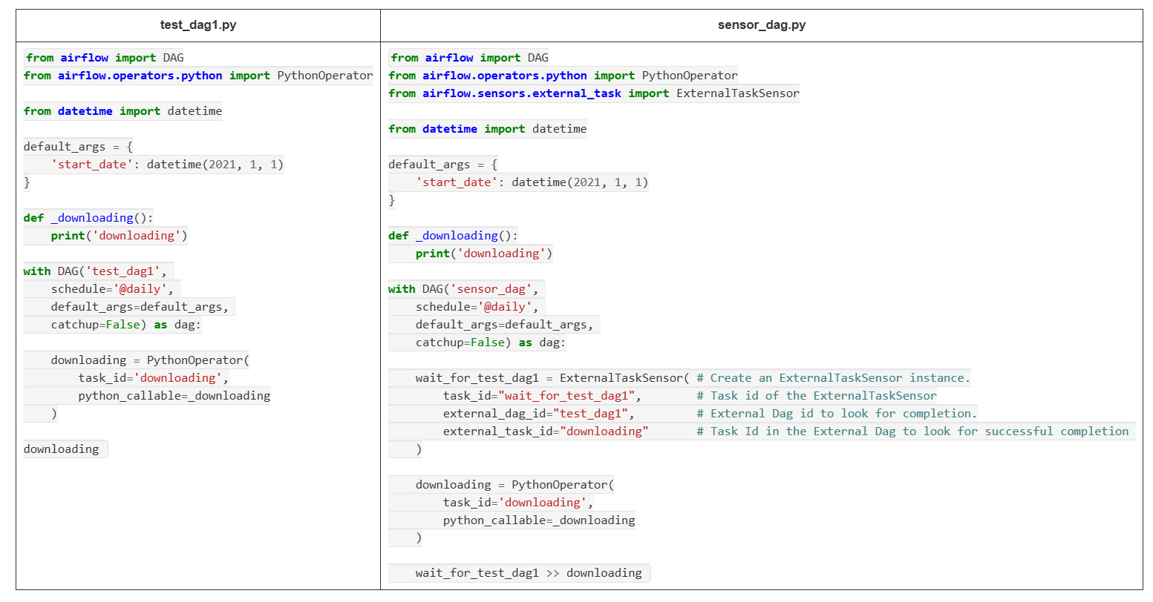

Access variables from your DAGs:-
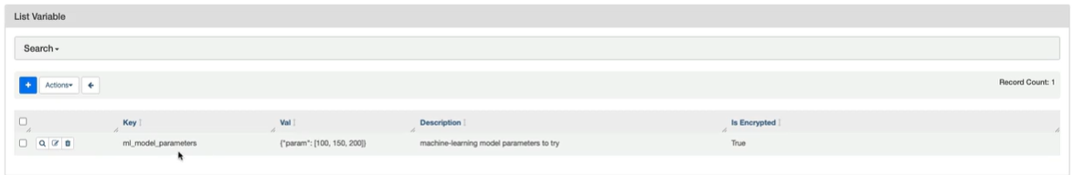

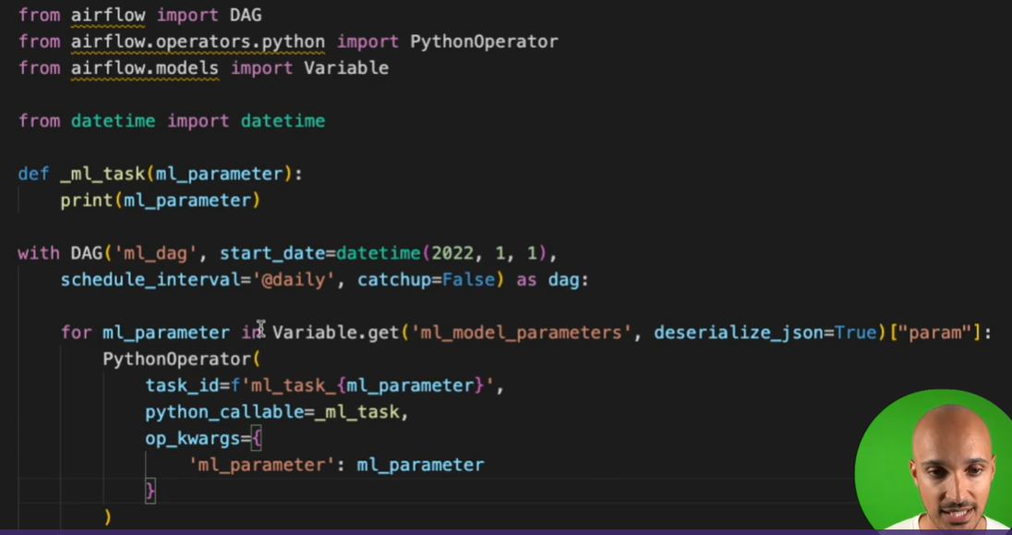

Variables using Jinja Templates:-

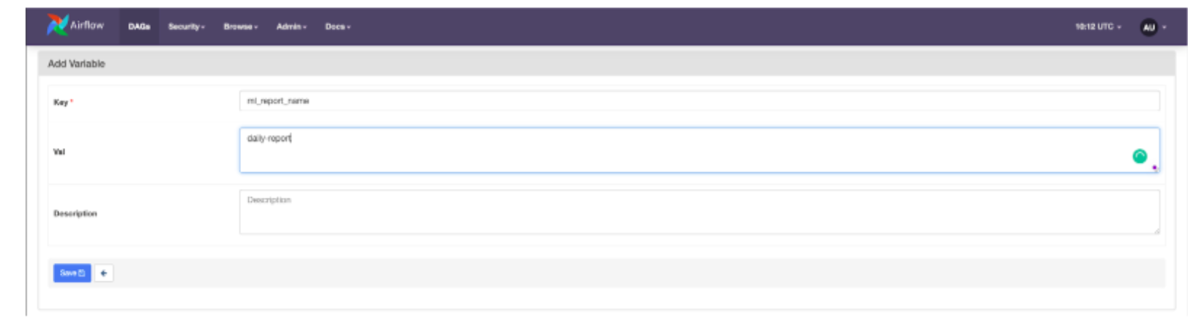

from airflow import DAG
from airflow.operators.python import PythonOperator
from airflow.operators.bash import BashOperator
from airflow.models import Variable
from datetime import datetime

def _ml_task(ml_parameter):
print(ml_parameter)

with DAG('ml_dag', start_date=datetime(2022, 1, 1),
schedule_interval='@daily', catchup=False) as dag:
ml_tasks = []
for ml_parameter in Variable.get('ml_model_parameters', deserialize_json=True)["param"]:
ml_tasks.append(PythonOperator(
task_id=f'ml_task_{ml_parameter}',
python_callable=_ml_task,
op_kwargs={
'ml_parameter': ml_parameter
}
))

report = BashOperator(
task_id='report',
bash_command='echo "report_{{ var.value.ml_report_name }}"' ## Jinja variable
)

Apache Airflow(Expiry is 5th July )

- Exam syllabus https://medium.com/%40ansam.yousry/test-your-knowledge-70-questions-on-apache-airflow-fundamentals-8bcb9dda6127
- Free certification link - https://academy.astronomer.io/astronomer-certified-apache-airflow-core-exam
- Learning path - https://academy.astronomer.io/path/airflow-101-airflow-2
- Prep path - https://rubyfaby.medium.com/apache-airflow-certificate-practices-exams-and-knowledge-sharing-2023-4ce5fdc95be1

AWS Backup

- https://collin-smith.medium.com/passing-the-aws-certified-data-engineer-associate-exam-in-2024-b2af6e6319b9s

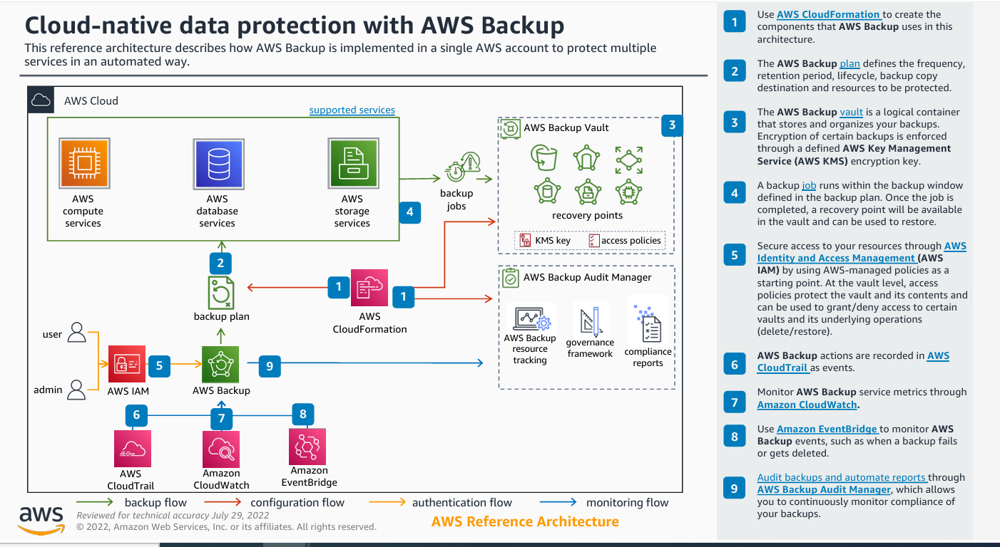

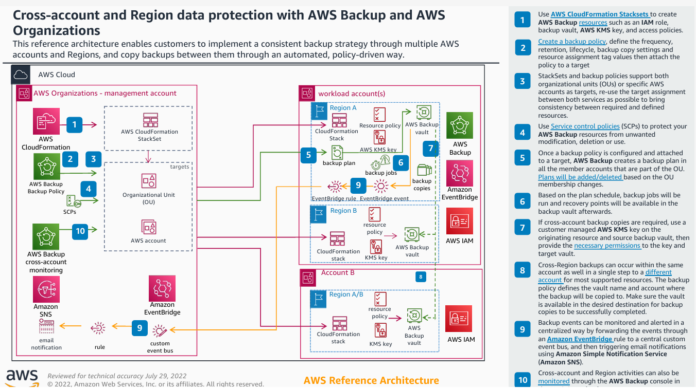

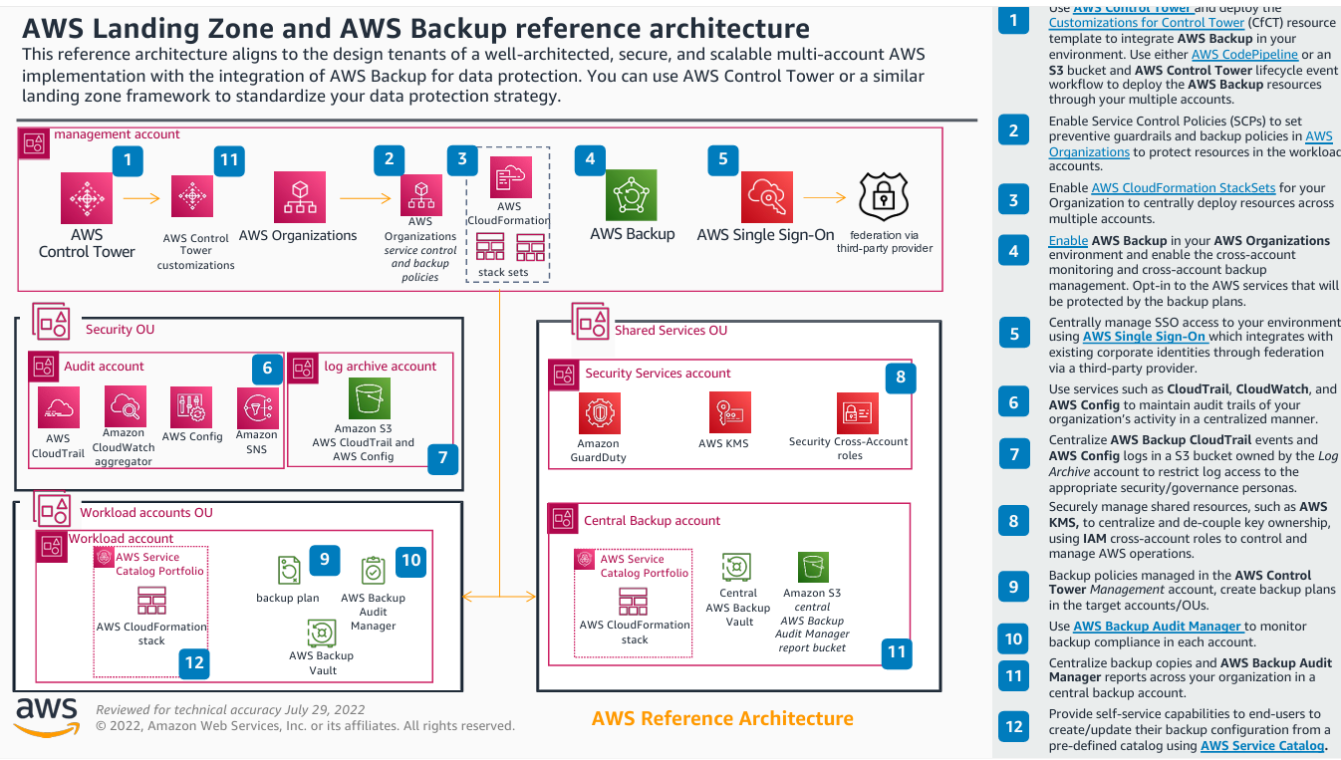

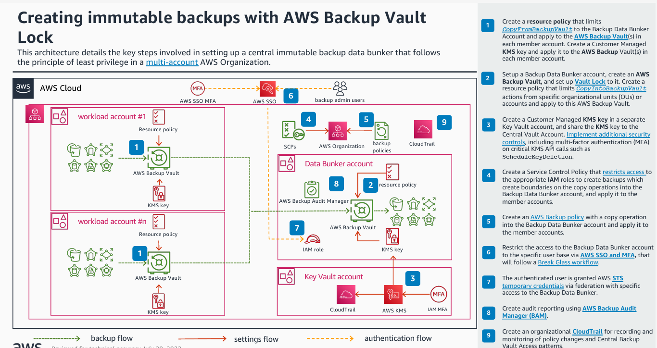

AWS ETL Pipeline
Link:- https://github.com/ankitbansal6/AWS-ETL-Pipeline/blob/main/orders_etl.json
YouTube:- https://www.youtube.com/watch?v=yHHCV3Q13Fo
import json
import boto3
import pandas as pd
import io
from datetime import datetime

def flatten(data):
orders_data=[]
for order in data:
for product in order['products']:
row_orders = {
"order_id" : order["order_id"],
"order_date" : order["order_date"],
"total_amount" : order["total_amount"],
"customer_id" : order["customer"]["customer_id"],
"customer_name" : order["customer"]["name"],
"email" : order["customer"]["email"],
"address" : order["customer"]["address"],
"product_id" : product["product_id"],
"product_name" : product["name"],
"category" : product["category"],
"price" : product["price"],
"quantity" : product["quantity"]
}
orders_data.append(row_orders)
df_orders = pd.DataFrame(orders_data)
return df_orders

def lambda_handler(event, context):
# TODO implement
bucket_name = event['Records'][0]['s3']['bucket']['name']
key=event['Records'][0]['s3']['object']['key']

s3 = boto3.client('s3')
response = s3.get_object(Bucket=bucket_name, Key=key)

# Read and parse JSON content
content = response['Body'].read().decode('utf-8')
data = json.loads(content)
df = flatten(data)

# in-memory binary buffer to hold data like a file, but without writing to disk.
parquet_buffer = io.BytesIO()
df.to_parquet(parquet_buffer, index=False, engine='pyarrow')

now = datetime.now()
timestamp = now.strftime("%Y%m%d_%H%M%S")

key_staging=f'orders_parquet_datalake/orders_ETL_{timestamp}.parquet'

s3.put_object(Bucket=bucket_name, Key=key_staging, Body=parquet_buffer.getvalue())

crawler_name = 'etl_pipeline_crawler'
glue = boto3.client('glue')
response = glue.start_crawler(Name=crawler_name)

Copy Command Example:- https://docs.aws.amazon.com/redshift/latest/dg/r_COPY_command_examples.html#load-from-csv

Python
DDB Stream -> Lambda -> Firehose -> S3 - > Redshift

Loading data from DynamoDB to Redshift approaches:-
- Using Data Pipelines
- Using DDB Streams -> AWS Lambda -> Kinesis -> Redshift
- Using DataFlux(Not available)
- Using Elastic Search (The data in DDB is also updated in ES)
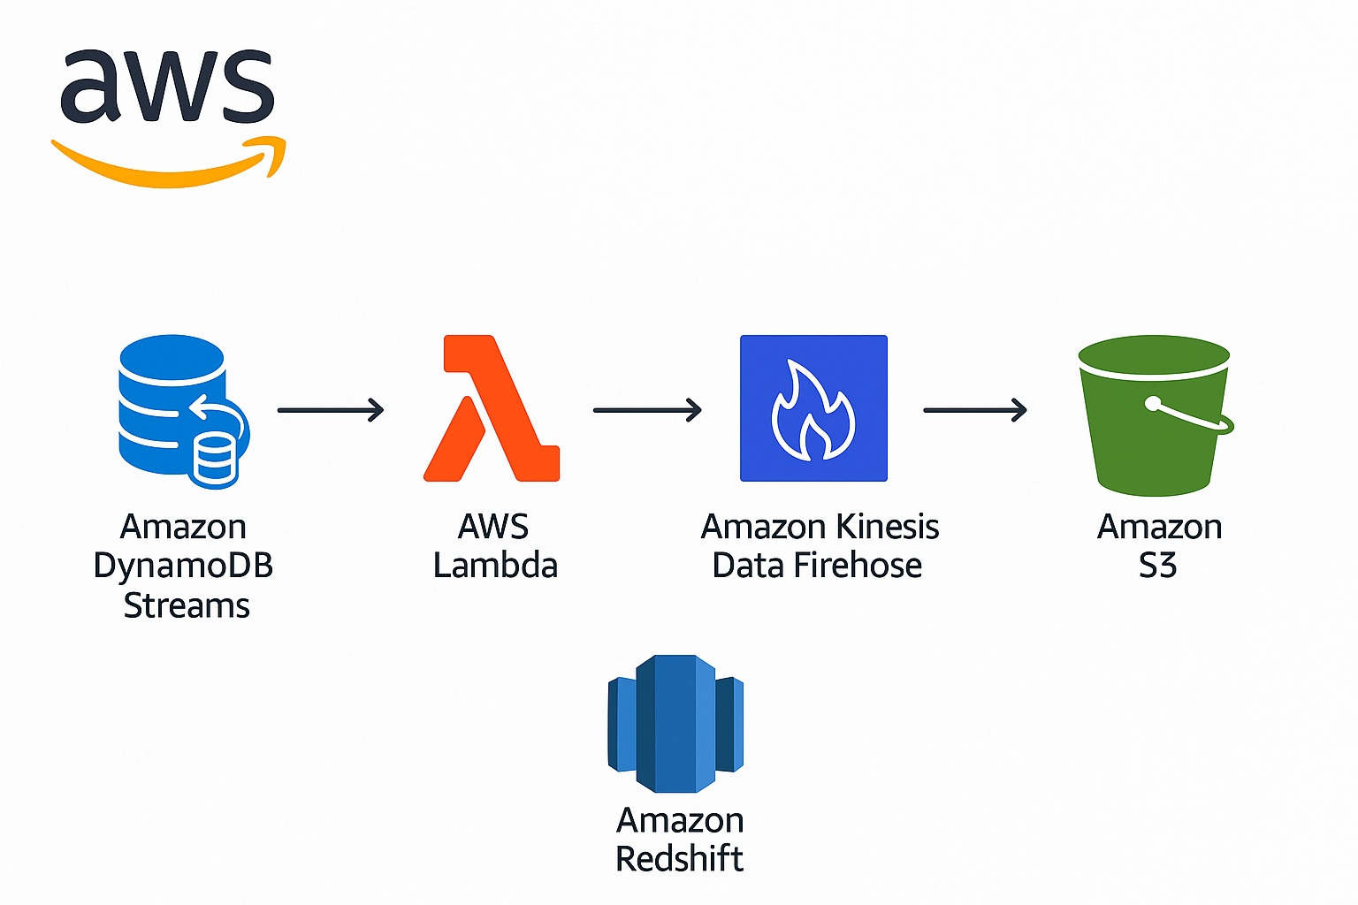

import boto3
import unicodedata
import base64

dynamodb = boto3.resource('dynamodb')
firehose = boto3.client('firehose')

def SendToFirehose(streamName, inputrecord):
print "Sending data to firehose ..."
response = firehose.put_record(
DeliveryStreamName = streamName,
Record= {
'Data' : inputrecord
}
)
print "Writing to firehose done..."

def lambda_handler(event, context):
firehoseName = 'test-stream-gupmanit'
print "Retrieving data from dynamodb..."
print event
for record in event['Records']:
print "The Record is :"
print record
#extract data from unicode dict
salesid_unicode_data = record['dynamodb']['NewImage']['salesid']['S']
dateid_unicode_data = record['dynamodb']['NewImage']['dateid']['S']
#convert data from unicode
salesid = unicodedata.normalize('NFKD', salesid_unicode_data).encode('ascii','ignore')
dateid = unicodedata.normalize('NFKD', dateid_unicode_data).encode('ascii','ignore')
#construct the record
inputrecord = ",".join([salesid, dateid]);
print "Input Record is : %s" % inputrecord
#append '\n' at the end of each record, for storage in S3.
inputrecord = inputrecord + '\n'
#m = {}
#/m['salesid'] = salesid
SendToFirehose(firehoseName, inputrecord)

Same as above only difference is instead S3 Buffer Size and S3 Buffer Interval parameters records are divided based on count in below program:-
from __future__ import print_function

import json
import urllib
import boto3
import unicodedata
import base64

s3 = boto3.client('s3')
firehose = boto3.client('firehose')

# Function to replace escape sequences in DDb data.
def replaceLine(t):
return t.replace('\n', '').replace('\r', '').replace('\t', '')

def quoteLine(t):
return '"{}"'.format(t)

# Function to send data to firehose stream.
def SendToFirehose(streamName, records, count):
# print("Sending data to firehose ...")

response = firehose.put_record_batch(
DeliveryStreamName = streamName,
Records = records
)

print("Writing to firehose done " + str(records))
# print("Number of records processed: " + str(count))

def lambda_handler(event, context):
firehoseName = 'backfill-csaas-ddb'
# print("Received event: " + json.dumps(event, indent=2))

# Get the object from the event
bucket = event['Records'][0]['s3']['bucket']['name']

key = urllib.unquote_plus(event['Records'][0]['s3']['object']['key'].encode('utf8'))

try:
response = s3.get_object(Bucket=bucket, Key=key)
json_data = response['Body'].read()
json_data = json_data.split("\n")

# print("Number of input records: " + str(len(json_data)))

count = 0
records = []

for line in json_data:
if line.strip() == "":
continue

json_object = json.loads(line)
# print(json_object)

attributeName = unicodedata.normalize('NFKD', json_object['attributeName']['s']).encode('ascii','ignore')
attributeValue = unicodedata.normalize('NFKD', json_object['attributeValue']['s']).encode('ascii','ignore')
buyerID = unicodedata.normalize('NFKD', json_object['buyerID']['s']).encode('ascii','ignore')
marketplaceID = unicodedata.normalize('NFKD', json_object['marketplaceID']['s']).encode('ascii','ignore')
orderID = unicodedata.normalize('NFKD', json_object['orderID']['s']).encode('ascii','ignore')
sellerID = unicodedata.normalize('NFKD', json_object['sellerID']['s']).encode('ascii','ignore')
timestamp = unicodedata.normalize('NFKD', json_object['timestamp']['n']).encode('ascii','ignore')

# quote each attribute and remove escape characters.
attributeName = quoteLine(replaceLine(attributeName));
attributeValue = quoteLine(replaceLine(attributeValue));
buyerID = quoteLine(replaceLine(buyerID));
marketplaceID = quoteLine(replaceLine(marketplaceID));
orderID = quoteLine(replaceLine(orderID));
sellerID = quoteLine(replaceLine(sellerID));
timestamp = quoteLine(replaceLine(timestamp));

# construct the record, csv file is expected by Redshift, order is important, should be same as Redshift.
inputrecord = ",".join([attributeName, attributeValue, buyerID, marketplaceID, orderID, sellerID, timestamp]);

# print("Input Record is :" + inputrecord)
# append '\n' at the end of each record, for storage in S3.

inputrecord = inputrecord + '\n'

record = {
'Data' : inputrecord
}

records.append(record)
count = count + 1
if count % 500 == 0:
SendToFirehose(firehoseName, records, count)
records = []

if len(records) > 0:
SendToFirehose(firehoseName, records, count)

print("Finished processing " + str(count) + " elements!")

except Exception as e:
print(e)
raise e

-:Apache Iceberg with Glue, s3 and Athena:-

S3 → AWS Glue ETL job (PySpark + Iceberg) → Iceberg table (stored on S3)
↓
Query via Athena, Glue, EMR, Trino, etc.

# Example: in a Glue script (Python shell or Glue notebook)
spark.sql("""
CREATE TABLE IF NOT EXISTS iceberg_db.sales (
order_id INT,
product STRING,
amount DOUBLE,
country STRING
)
USING iceberg
LOCATION 's3://my-bucket/warehouse/iceberg_db/sales'
""")
## This table is now Iceberg-managed and stored on S3.

## Insert
new_data = [
(201, "Monitor", 200.0, "US"),
(202, "Keyboard", 70.0, "UK")
]
columns = ["order_id", "product", "amount", "country"]

## Insert and append Data
df = spark.createDataFrame(new_data, columns)
df.writeTo("iceberg_db.sales").append()

## QUery Data
df_query = spark.sql("SELECT * FROM iceberg_db.sales")
df_query.show()

## Update Data
spark.sql("""
UPDATE iceberg_db.sales
SET amount = 75.0
WHERE order_id = 202
""")

##Delete
spark.sql("""
DELETE FROM iceberg_db.sales
WHERE country = 'UK'
""")

##Time travel (query old snapshot)
snapshots = spark.sql("""
SELECT * FROM iceberg_db.sales.snapshots
""")
snapshots.show()
##Query by snapshot ID
snapshot_id = "<snapshot_id>"
df_old = spark.read.option("snapshot-id", snapshot_id).table("iceberg_db.sales")
df_old.show()

##Tables live in S3, but you get database-like ACID guarantees
##Glue ETL jobs can write/update/delete
##Athena, EMR, Trino, Redshift Spectrum can query the same Iceberg tables
##Supports batch and streaming writes

Here are the links typed out from the image you shared:
- Comparison of Data Lake Table Formats (Iceberg perspective):
https://www.dremio.com/subsurface/comparison-of-data-lake-table-formats-iceberg-hudi-and-delta-lake/
- Apache Hudi vs Delta Lake vs Apache Iceberg - Lakehouse Feature Comparison (Hudi perspective):
https://www.onehouse.ai/blog/apache-hudi-vs-delta-lake-vs-apache-iceberg-lakehouse-feature-comparison
- A Thorough Comparison of Delta Lake, Iceberg and Hudi (Delta Lake perspective):
https://www.slideshare.net/databricks/a-thorough-comparison-of-delta-lake-iceberg-and-hudi

Experiment with s3 and hudi - https://medium.com/@mattgillard/my-s3-tables-experiment-a789493c5512

Open table formats on AWS:- https://catalog.us-east-1.prod.workshops.aws/workshops/520e974c-0fee-4585-9601-9af535d4d908/en-US/0-introduction
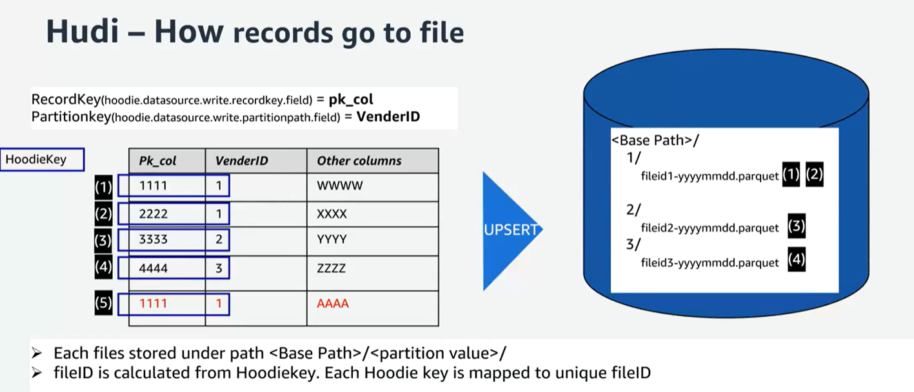

EMR:-
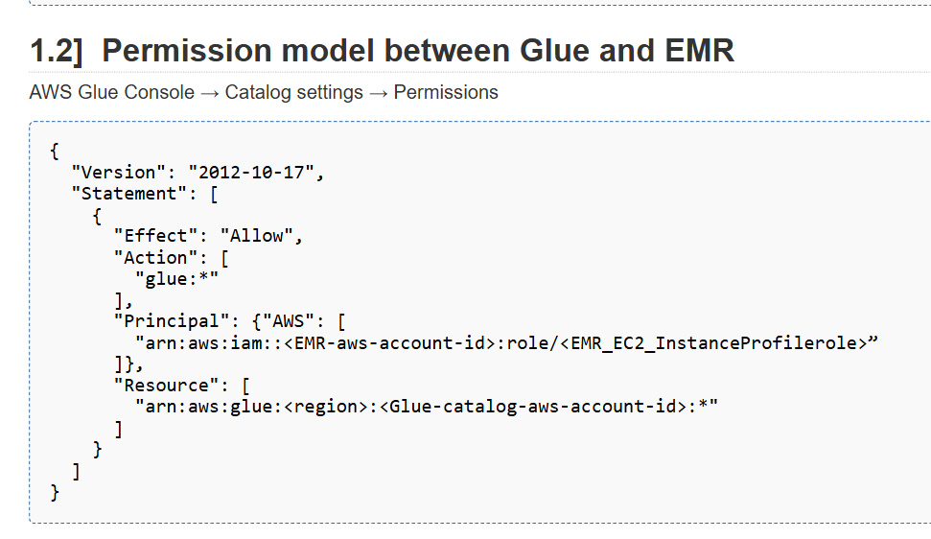

AWS Opensearch:- https://medium.com/globant/implementing-an-amazon-opensearch-service-productivity-cluster-b54182e0732a
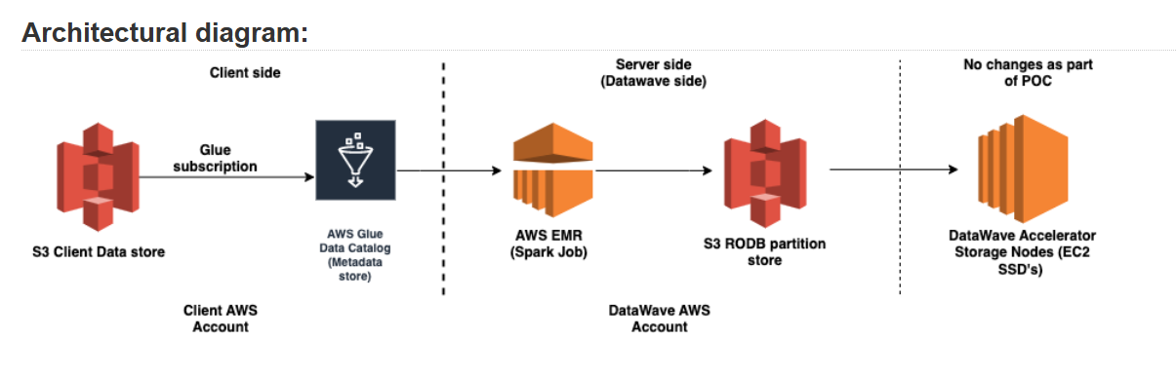

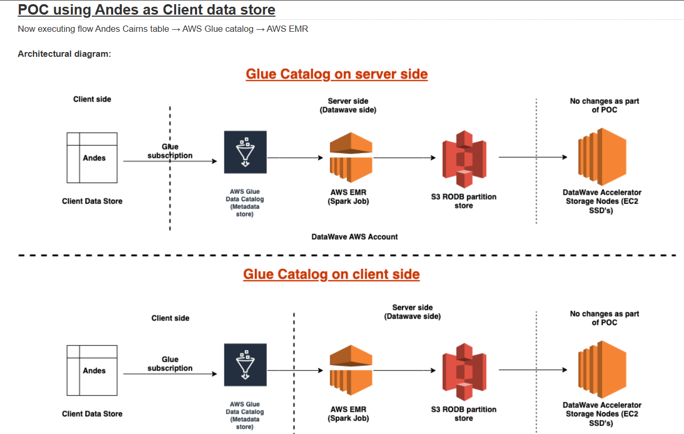

kinesis Firehose — transformations with lambda, data conversions and dynamic partitioning

https://medium.com/@prakashabhishant/kinesis-firehose-transformations-with-lambda-data-conversions-and-dynamic-partitioning-aefb189aa2ed

AWS Kinesis Data Streams with CDK Python — Part 1
https://medium.com/@prakashabhishant/aws-kinesis-data-streams-with-cdk-python-part-1-e9eac3431b94

https://medium.com/@prakashabhishant/kinesis-firehose-transformations-with-lambda-data-conversions-and-dynamic-partitioning-aefb189aa2ed

-:SQS:-

##Python
import boto3

# Create SQS client
sqs = boto3.client('sqs', region_name='us-east-1')

queue_url = 'https://sqs.us-east-1.amazonaws.com/123456789012/MyQueue'

# Send a message
response = sqs.send_message(
QueueUrl=queue_url,
MessageBody='Hello from SQS!',
DelaySeconds=5
)
print("MessageId:", response['MessageId'])

# Receive messages
messages = sqs.receive_message(
QueueUrl=queue_url,
MaxNumberOfMessages=2,
WaitTimeSeconds=5
)

if "Messages" in messages:
for msg in messages['Messages']:
print("Received:", msg['Body'])
# Delete after processing
sqs.delete_message(
QueueUrl=queue_url,
ReceiptHandle=msg['ReceiptHandle']
)

JAVA
##JAVA Example
import software.amazon.awssdk.services.sqs.SqsClient;
import software.amaz
on.awssdk.services.sqs.model.*;

public class SqsExample {
public static void main(String[] args) {
SqsClient sqsClient = SqsClient.builder().region(Region.US_EAST_1).build();

String queueUrl = "https://sqs.us-east-1.amazonaws.com/123456789012/MyQueue";

// Send message
SendMessageResponse sendResponse = sqsClient.sendMessage(
SendMessageRequest.builder()
.queueUrl(queueUrl)
.messageBody("Hello from Java!")
.delaySeconds(5)
.build()
);
System.out.println("Message ID: " + sendResponse.messageId());

// Receive messages
ReceiveMessageResponse receiveResponse = sqsClient.receiveMessage(
ReceiveMessageRequest.builder()
.queueUrl(queueUrl)
.maxNumberOfMessages(2)
.waitTimeSeconds(5)
.build()
);

for (Message msg : receiveResponse.messages()) {
System.out.println("Received: " + msg.body());
sqsClient.deleteMessage(DeleteMessageRequest.builder()
.queueUrl(queueUrl)
.receiptHandle(msg.receiptHandle())
.build()
);
}
}
}

##1. How it Works
##A file is uploaded to S3.
##S3 sends an event notification to an SQS queue.
##The SQS queue holds the event (so messages aren’t lost even if Lambda is busy).

##A Lambda function polls the queue and processes the file (e.g., read, transform, move).

#####CDK Python COde
from aws_cdk import (
Stack,
aws_s3 as s3,
aws_sqs as sqs,
aws_lambda as _lambda,
aws_lambda_event_sources as event_sources,
aws_iam as iam,
aws_s3_notifications as s3n,
)
from constructs import Construct

class S3SqsLambdaStack(Stack):

def __init__(self, scope: Construct, construct_id: str, **kwargs):
super().__init__(scope, construct_id, **kwargs)

# 1. S3 bucket
bucket = s3.Bucket(
self, "MyBucket",
versioned=True,
removal_policy=cdk.RemovalPolicy.DESTROY,
auto_delete_objects=True
)

# 2. SQS queue
queue = sqs.Queue(
self, "MyQueue",
visibility_timeout=cdk.Duration.seconds(60), # match Lambda timeout
retention_period=cdk.Duration.days(4)
)

# 3. Lambda function
lambda_fn = _lambda.Function(
self, "MyLambda",
runtime=_lambda.Runtime.PYTHON_3_11,
handler="lambda_function.handler",
code=_lambda.Code.from_inline(
"""
import boto3, json

def handler(event, context):
print("Event:", json.dumps(event))
for record in event['Records']:
body = json.loads(record['body'])
s3_info = body['Records'][0]['s3']
bucket = s3_info['bucket']['name']
key = s3_info['object']['key']
print(f"Processing file: s3://{bucket}/{key}")
return {"status": "done"}
"""
),
timeout=cdk.Duration.seconds(60),
)

# Grant Lambda permission to read from S3
bucket.grant_read(lambda_fn)

# 4. Add SQS as event source for Lambda
lambda_fn.add_event_source(event_sources.SqsEventSource(queue))

# 5. Add S3 → SQS notification
bucket.add_event_notification(
s3.EventType.OBJECT_CREATED,
s3n.SqsDestination(queue)
)

##Flow After Deployment
##Upload a file to the created S3 bucket.
##S3 sends event → SQS.
##Lambda polls SQS, processes the file.
##You’ll see file details printed in CloudWatch Logs.

AWS Step Function

  - AWS Step Functions let you build serverless workflows that coordinate multiple AWS services (like Lambda, ECS, Glue, SageMaker, etc.) into a single state machine.
  - Each “step” represents a task, and the flow between them defines how your application runs — including branching, retries, and error handling.

Types of state: -
State Type | Purpose
Task | Run work (Lambda, Glue, ECS, etc.)
Choice | Conditional branching
Wait | Delay or pause
Succeed | End execution successfully
Fail | End execution with error
Parallel | Run multiple branches concurrently
Map | Iterate over an array (loop)
Pass | Pass data without doing work

